Solution 1:

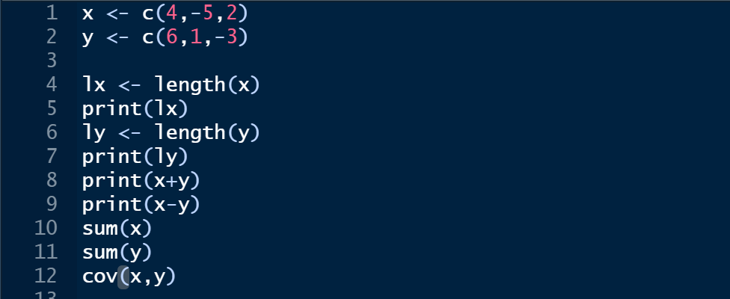

Output:

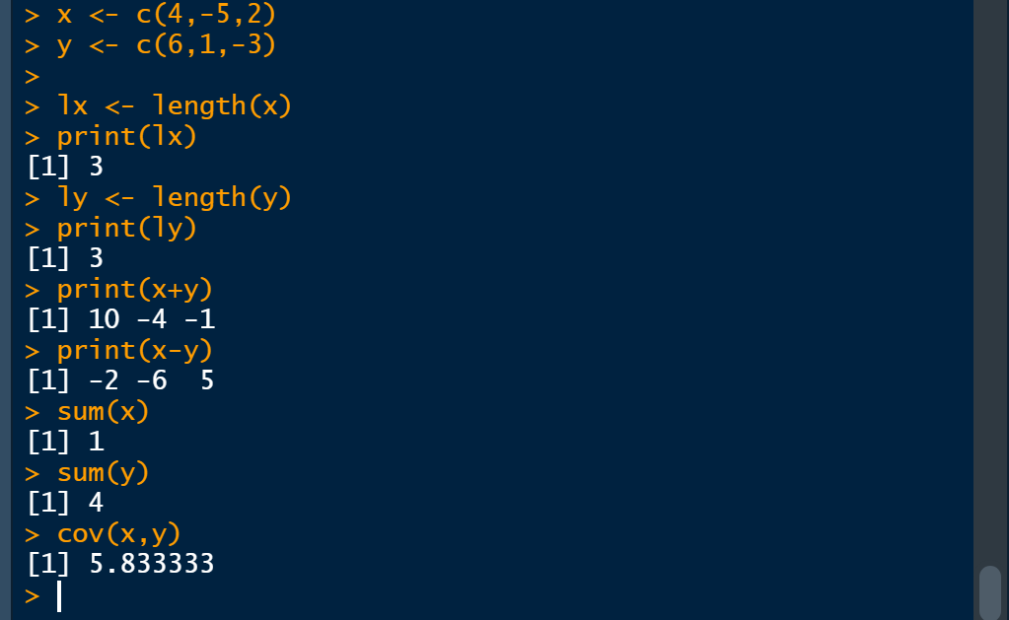

Solution 2:

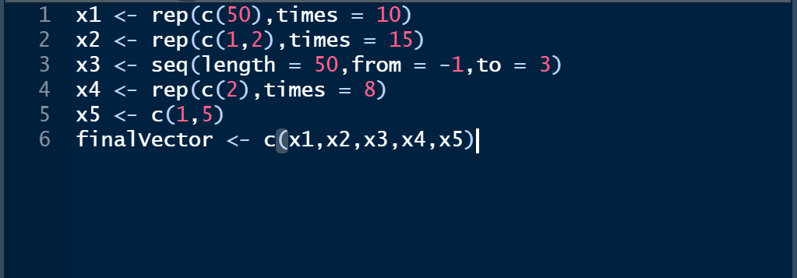

Output:

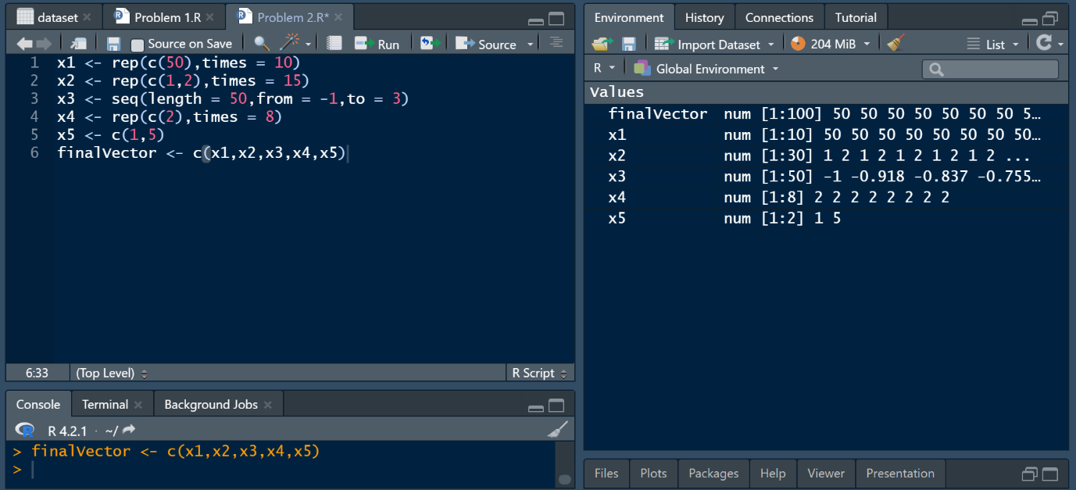

Solution 3:

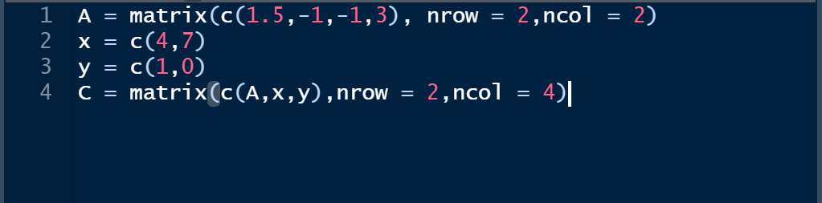

Output:

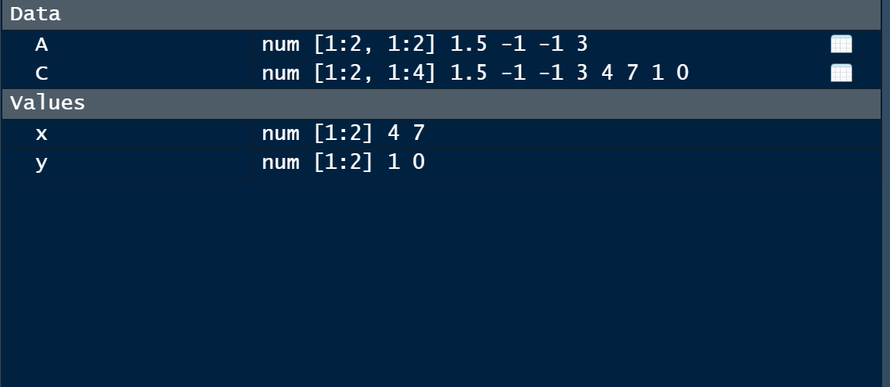

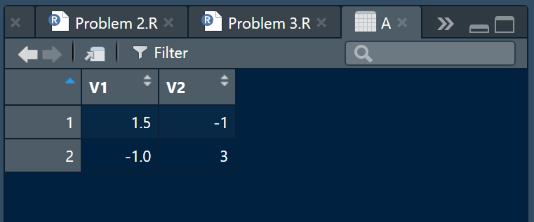

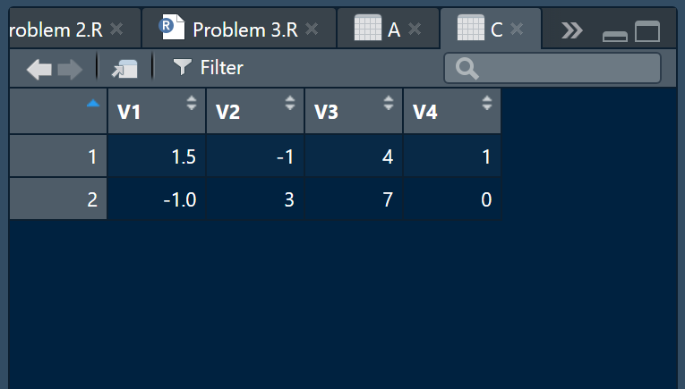

Solution 4:

tempA <- matrix(c(3,-1,-2,4),nrow = 2,ncol = 2)

A <- cbind(tempA,c(1,-2))

tempB <- matrix(c(-7,4,9,5),nrow = 2,ncol = 2, byrow = T)

B <- rbind(tempB,c(2,-1))

multiplicationAB <- A%\*%B

print(multiplicationAB)

transposeAB <- t(multiplicationAB)

print(transposeAB)

inverseAB <- solve(multiplicationAB)

print(inverseAB)

rowMeans(A); colMeans(A)

rowMeans(B); colMeans(B)

rowMeans(multiplicationAB); colMeans(multiplicationAB)

rowMeans(transposeAB); colMeans(transposeAB)

rowMeans(inverseAB); colMeans(inverseAB)

sd(A[,1]); sd(A[,2]); sd(A[,3])

sd(A[1,]); sd(A[2,])

sd(B[,1]); sd(B[,2])

sd(B[1,]); sd(B[2,]); sd(B[3,])

sd(multiplicationAB[,1]); sd(multiplicationAB[,2])

sd(multiplicationAB[1,]); sd(multiplicationAB[2,])

sd(transposeAB[,1]); sd(transposeAB[,2])

sd(transposeAB[1,]); sd(transposeAB[2,])

sd(inverseAB[,1]); sd(inverseAB[,2])

sd(inverseAB[1,]); sd(inverseAB[2,])

Output:

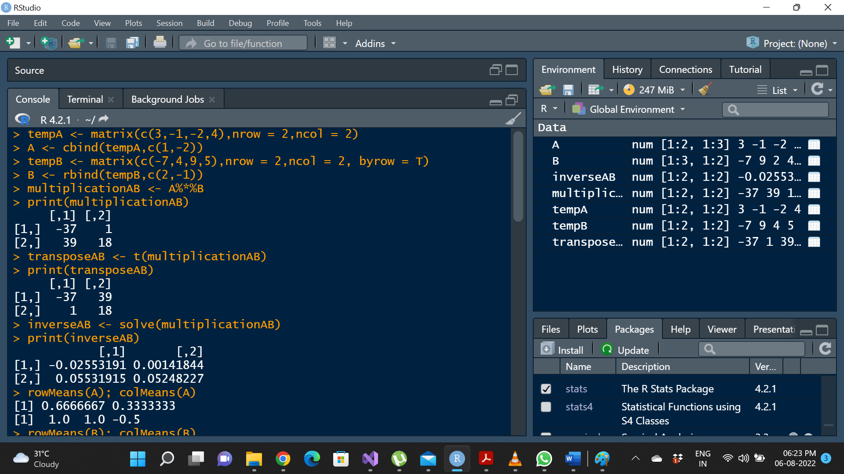

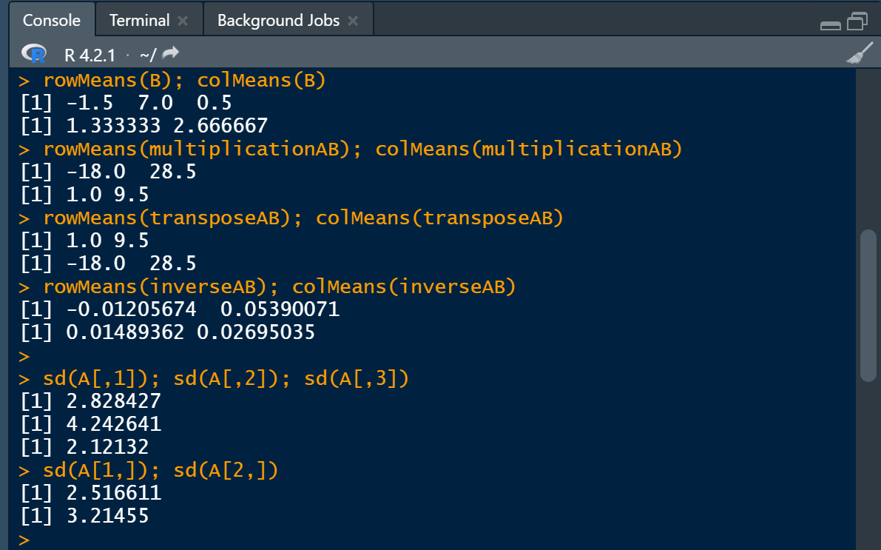

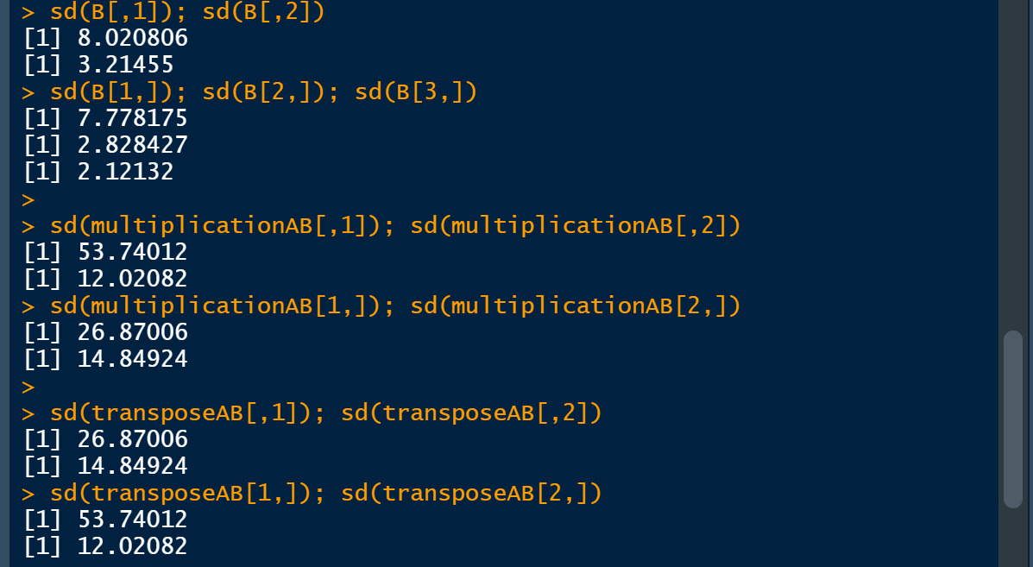

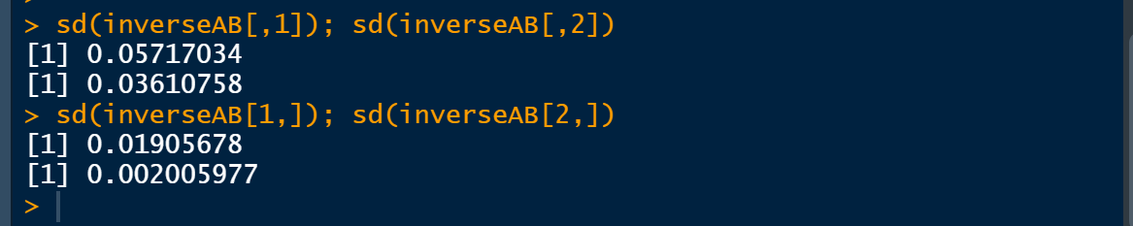

Solution 5:

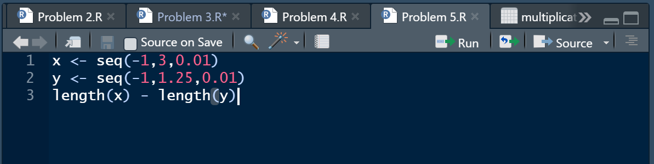

OR

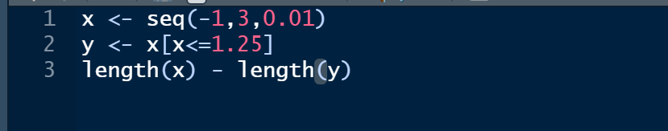

Output:

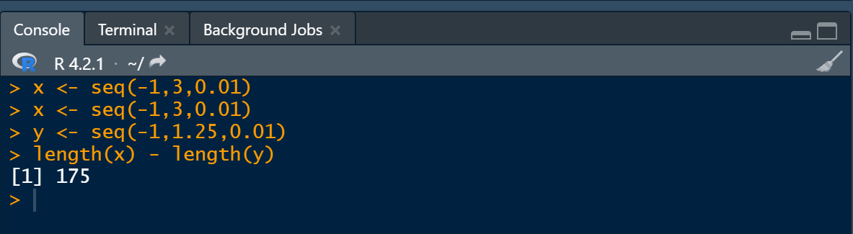

OR

